Chapter 18, Solution 69.

The total energy is

W_{T} = 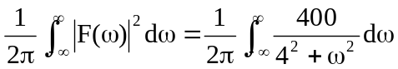

= 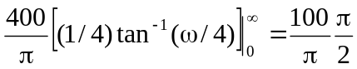 = 50

W = 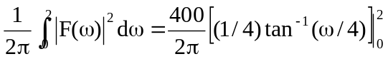

= [100/(2π)]tan^{–1}(2) = (50/π)(1.107) = 17.6187

W/W_{T} = 17.6187/50 = 0.3524 or 35.24%

